Logbook

# Semester 1

# Week 1 (3 hours)

19/09/2022

Dr Norman Murray gave a lecture about the final year project and how to do work on it.

The final year project is worth 40 credits which is 1 third of the final year.

Dr Norman talked about how to make a good start to the project, he suggested that we read the project guide properly, and that we should scope the project properly and that we need to make a realistic project plan. He also said that we should give this project about 2 days a week to work on as it is worth a lot of credits. He also told us to keep our logbook updated.

He talked about the project life cycle which includes:

Choosing the project

Managing the project

Doing the project

Presenting the project

He then talked about how to propose our own project. To do this, the project needs to be challenging to do, must be realistic to do, produce a software/website,

Identify the customer, provide a title, description and a plan and then find a member of staff to act as a supervisor.

Dr Norman also talked about the risk assessment form that we need to put in by the end of week 5. This a requirement from the university so that we can do the final year project. I need to read, understand, completed, and signed by me and my supervisor.

Dr Norman also talked about the Ethical approval form that we also need to put in by the end of week 5. This is another requirement from the university so that we can do the final year project. I need to read, understand, completed, and signed by me and my supervisor.

The final year project module has a few components that need to be done throughout the year, these are:

Project proposal

Introduction, Literature Review and Methodology

Requirements, Design and Implementation, Testing and Evaluation, Discussion, Critical Evaluation, Reflection

Project Presentation and Final Product

Dr Norman also talked about how to avoid plagiarism and what the consequences of plagiarism are.

## Independent Research / Study

I was on a placement year last year at brakes manufacturing company called Knorr-Bremse. My job role was IT Placement student. I had learnt a lot about managing projects, understanding the workload, figuring out where to get help, and how to work on my own in a professional manner. I think the skills that I have learnt will be very beneficial to me while working on the Final Year Project.

The change from working a job and going back to study has been a difficult one for me, as I haven’t done much studying outside of work as I was living on my own and had other responsibilities to manage.

The idea for my project was not finalised yet, I knew that I wanted to do a game development project, but I was not sure on how to start it and what I needed to do. I took advantage of the trial period of modules and went to Dr Normans Lecture on game development, he gave me a few ideas on how to make a successful game project. One of the ideas that he gave that stood out to me was the idea about a game based around lighting.

I also went to Dr Ian Drumm’s lecture on mobile development to see if making a game for a mobile device would be feasible for me, he suggested that I could use the unity game engine to develop games for mobile.

# Week 2 (8 hours)

26/09/2020 – 30/09/2022

Dr Norman Murray gave a lecture about the project proposal.

He told us that the project proposal needs to be no more than 1500 words, and it needs to append to this logbook.

The project is important as it reduces the risk of the final product being different than the supervisor expected. It also helps us to keep our focus on the important goals.

Dr Norman gave us a structure of the project proposal:

Introduction

What are you going to research/develop?

Who is it for? Who will benefit?

Why are you doing this?

How are you going to do it?

Objectives

Gantt Chart of objectives to show timeliness and all your deadlines.

Development requirements/ methodology

Logbook

Presented well and written in competent technical English.

Dr Norman also talked about how our objective should be smart objectives:

Specific, states exactly what you need to achieve.

Measurable, includes a quality or quantity measure.

Agreed, between you and your supervisor.

Realistic, can be challenging but must be achievable.

Timebound, with a clear end date or timescale

Dr Norman also talked about which methodologies that we need to use, and what the hardware requirements are. He also talked about the end of project presentation and what standard it should be made at.

He also gave a reminder to complete the risk assessment and ethical form.

## Independent Research / Study

This week I started doing research on the unity game engine. The research led me to the Unity Render Pipeline, and that there are 2 pipelines, which are Universal Render Pipeline (URP) and High-Definition Render Pipeline (HDRP).

I also started to watch tutorials from Brackeys about making a game with the Unity game engine. He has many useful tutorials that are very beginner friendly.

# Week 3 (8 hours)

03/10/2022 – 07/10/2022

Dr Julian Bass gave a lecture about project development methods.

Dr Jullian talked about the reason for having the final year project, which is to meet the requirement for the BCS chartered institute of IT. He also talked about the Agile methodology in software development and how it works and why it is needed. The reason we use a methodology in software development, is that it maximises productivity and reduces risk.

## Independent Research / Study

Idea for lighting happened here.

The research from the previous week has now allowed me to pick a topic for the game development project. The idea is to make a unity a lighting game this would be good way to show off how lighting works in games. I also decided to use the HDRP pipeline for this project as it should give me the best result for the lighting in the game.

This week I also started to plan my project proposal as it was due on week 5 21st October, and I have my other modules to work on as well.

# Week 4 (6 hours)

10/10/2022 – 14/10/20200

Dr Chris Hughes gave a lecture about research methods.

Research is the study of people for the purpose of increasing your understanding or adding to knowledge.

Students do the final year project to allow them to develop their own thoughts, ideas and concepts so that they can question and look at things in new ways. It also allows the student to work on multiple modules at the same time. It also allows students to develop new skills. The student can contribute to the topic.

The processes of research are:

Review the Field.

Build a theory/hypothesis.

Test the theory/hypothesis.

Reflection and integration

Dr Chris talked to us about the literature review that we need to complete for the final year project. The literature review acts like an introduction to your project, it gives a reason to why you are doing the project, it shows the past and current research on your topic, and it also provides you supervisor and other researchers a starting point from where you project started from.

## Independent Research / Study

My focus for this week was to get the first draft of the project proposal done and emailed to my supervisors for the project. The first thing that I focused on was the Who will benefit part, this is an important part as it outlines why the project should exist.

After that, I wrote up the development requirements for the project. This was important because the Unity Game engine requires a lot of GPU and CPU power to run.

Then I wrote up a draft of my objectives and optional objectives. After that wrote up my methodology for the project. For this project I think I am going to work with the agile methodology.

Then I wrote an Introduction to the document and then added this logbook to the proposal by using a link and then I made the entire project look professional.

# Week 5 (8 hours)

17/10/2022 – 21/10/2022

Lee Griffiths gave a lecture about Requirements engineering.

The summary of this lecture is that we should talk to the people that will use the software, understand what exactly needs to be built, do not over promise and under deliver, go back and talk again and keep them in the loop of what is happening and test the software with them. Lee also talked about the role of requirements in software projects that failed. It showed us the importance of understanding the user requirements.

Lee showed us the relative cost of fixing errors in a software application. The highest cost is when the application has been released and the software still has errors.

He also showed us the relative cost of software development stages, and the highest cost was maintaining the software after it was released.

He showed us a box diagram of effort to impact in software development.

Here is a picture of it:

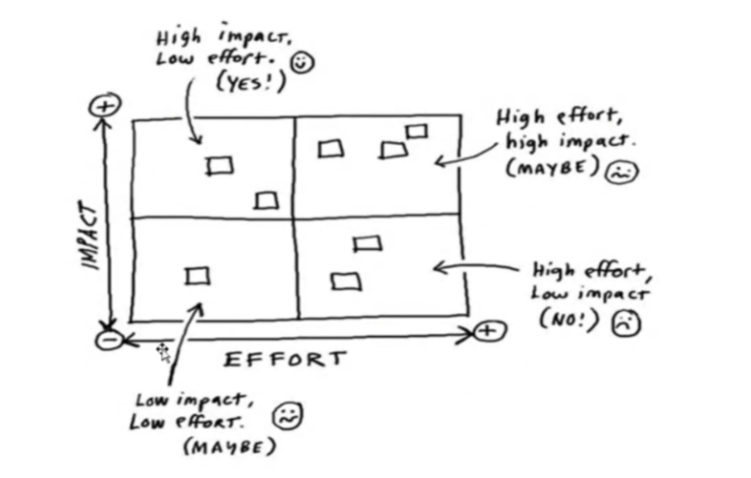

## Independent Research / Study

Once I got feedback from my supervisors, I updated my project proposal with the feedback that was given to me.

The main feedback that I was given was that my aims where not too clear. The aims needed to be milestones, learning isnt the only objective.

I have now submitted my proposal for marking.

# Week 6 (6 hours)

24/10/2022 – 28/10/2022

Julian Bass gave a lecture about the introduction and literature review about our final year project. This was the first part of the dissertation that had to be done and it will be assessed.

Julian Bass talked about the different approaches to writing, how the different parts should be composed like sentences and paragraphs, how to write a good introduction, literature review and methodology.

Julian Bass explained the importance on writing multiple drafts and having them checked repeatedly. He also emphasised the use of spell checkers and grammar checkers. He also talked about the main goals of the minimal viable product.

## Independent Research / Study

This week, I was informed about the risk assessment and that it needed to be done for my final year project.

Ive had an issue with the risk assessment, after submitting the risk assessment, there was an issue where my supervisor couldn’t see the risk assessment. This issue still hasn’t been resolved. This has wasted quite a bit of time for me.

# Week 7 (6 hours)

31/10/2022 – 04/11/2022

Lee Griffiths gave a lecture about requirements engineering this week.

The FYP lecture by Lee Griffiths focused on gathering requirements engineering for a project and ensuring that requirements meet customers' expectations. Lee emphasized the importance of not being over-ambitious in terms of features and consistently evaluating the software. The lecture highlighted a model that demonstrated the role of poor requirements and communication in software project failures. Lee discussed the relative costs of software development stages and the importance of design in the development process. Lee finished the lecture by giving tips on what to discuss within requirements of the deliverables. If this lecture were given earlier, it would have been helpful, as I have already submitted my project proposal.

## Independent Research / Study

This week the risk assessment issue got resolved. My supervisor is going to check the email attachment one instead.

I have now also started a Unity HDRP Lighting tutorial. It is one that is built into the Unity engine editor. 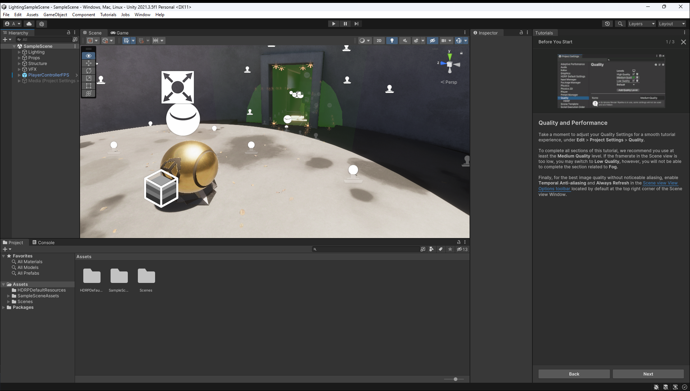

So far, the tutorial seems to be easy to follow, but there is quite a lot to go through.

# Week 8 Last Lecture of semester 1 (5 hours)

07/11/2022 – 11/11/2022

Ian Drumm gave a lecture this week about software architecture.

Dr Ian Drum's lecture on software architecture provided useful insights for my lighting project. Ian discussed the development of abstraction techniques in computer science and various architectural styles, along with their advantages and disadvantages. He also discussed various levels of design, such as OOP and MVC, and client-server systems. The lecture provided the me with a better understanding of different architectural designs that I can implement into my final year project. Overall, the lecture was helpful and gave the me lots of valuable information to consider.

## Independent Research / Study

I have now finished the HDRP tutorials, and I am now watching a Brackeys tutorial to gain more knowledge on game design, map design and character movement.

# Week 9 -no more lectures (2 hours)

14/11/2022 – 18/11/2022

## Independent Research / Study

The start of this week I was following a Brackeys tutorial on movement.

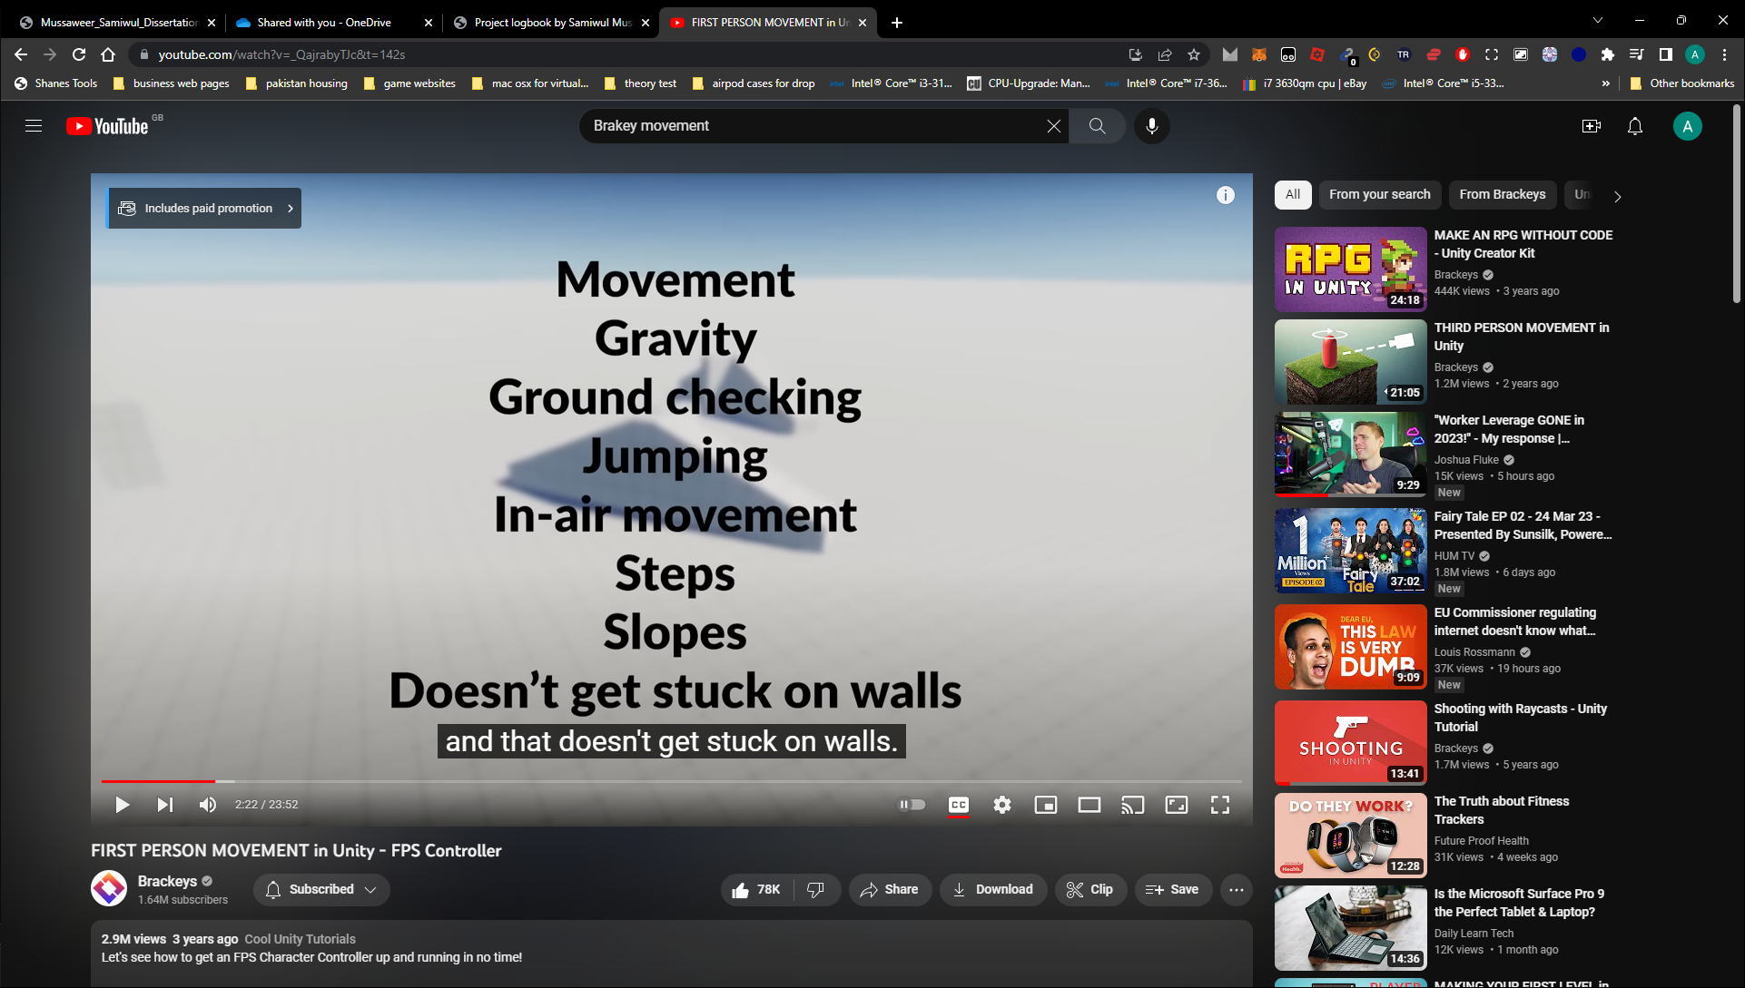

Halfway through the week, my parents decided that the roof needed to be done and they needed to remove all the chimneys in the house. For this reason, I was unable to finish the tutorial as my room is the loft and that was the first room affected. I do not have access to my computer anymore, I am currently working on an iPad to do more research.

# Week 10 - no more lectures (8 hours)

21/11/2022 – 25/11/2022

## Independent Research / Study

Construction work

I was doing research on the process of game development, I have been watching videos and reading articles on this aswell, I was taking notes in a OneNote file.

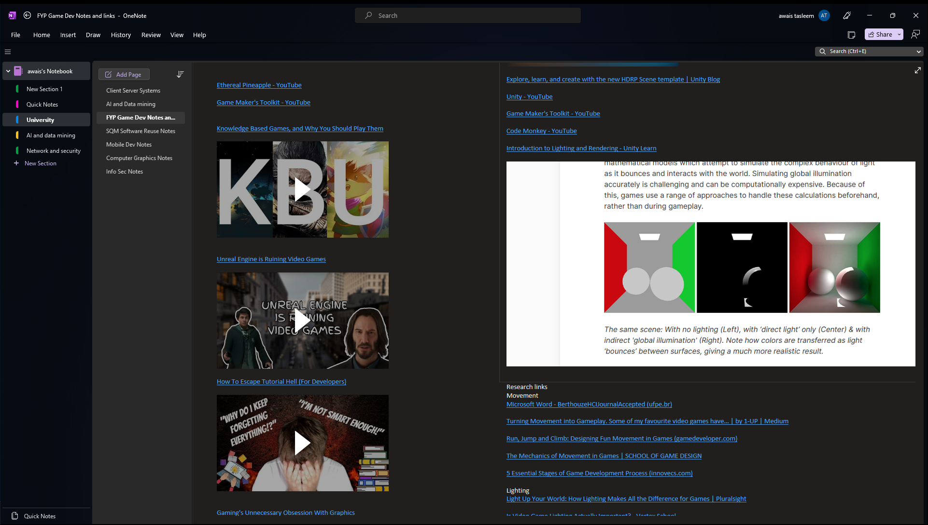

I have also started work on the first draft of the literature review and methodology. So far, I have completed the Lighting section, the Rendering Pipeline in Unity, HDRP vs URP and DRM and security issues game development.

# Week 11 - no more lectures (8 hours)

28/11/2022 – 02-12-2022

## Independent Research / Study

Construction work

This week I have fully completed the Literature review and methodology. I have talked about the methodology that is going to be used, the programming tools that are needed. And a summary and introduction. I have also emailed the first draft to my supervisors aswell.

They have provided feedback on the report, the feedback was that I need to focus a bit more on the security side of the project.

# Week 12 - no more lectures (1 hour)

05/12/2022 – 09/12/2022

## Independent Research / Study

Construction work

I submitted the assignment on Monday. I have not done any more work on the project as I have other deadlines for other projects that need to be done as well.

Literature review and Methodology Submission 05/12/2022

## Week 13 – no more lectures

12/12/2022 – 16/12/2022

## Independent Research / Study

Construction work

I have not done any more work on the project as I have other deadlines for other projects that need to be done as well.

4 Weeks Christmas Vacation – 17/12/2022 – 15/01/2023

Issue with Unity contacted Unity Support.

# Semester 2

# Week 1 (4 hours)

16/01/2023 – 20/01/2023

## Independent Research / Study

The construction work finished on the 8th of January 2023. I am now able to use my PC again to develop the project instead of just doing research on a laptop.

Started the MVP demo.

I have gotten a basic map made with some basic unity models. I have also coded a basic character controller so that I can go around the map. I followed Brackeys tutorial to make the controller work.

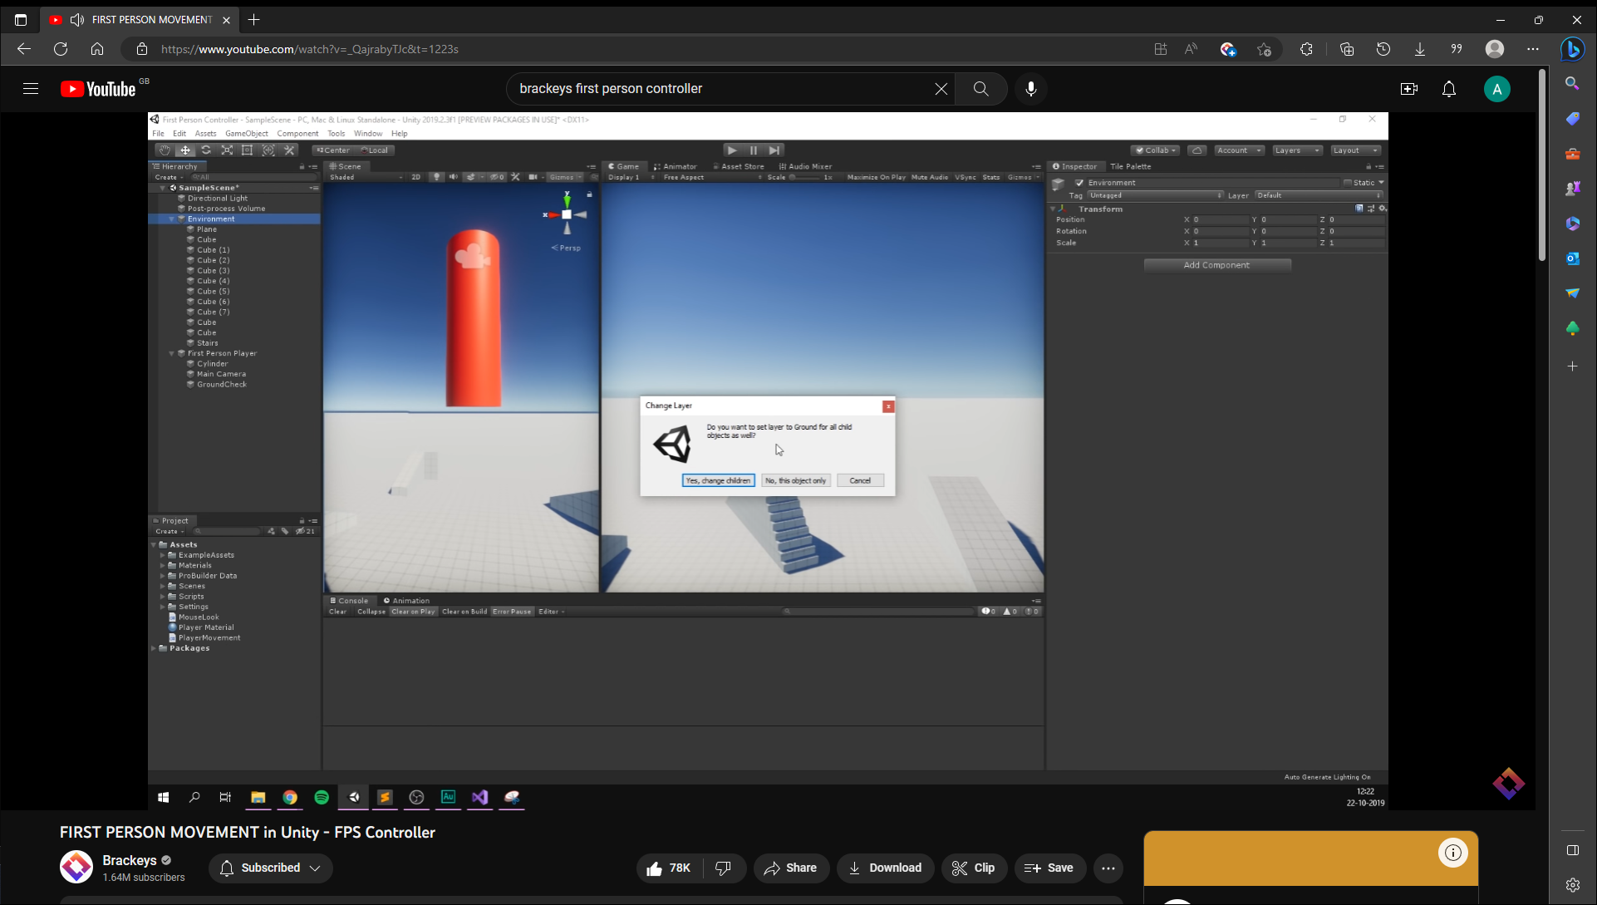

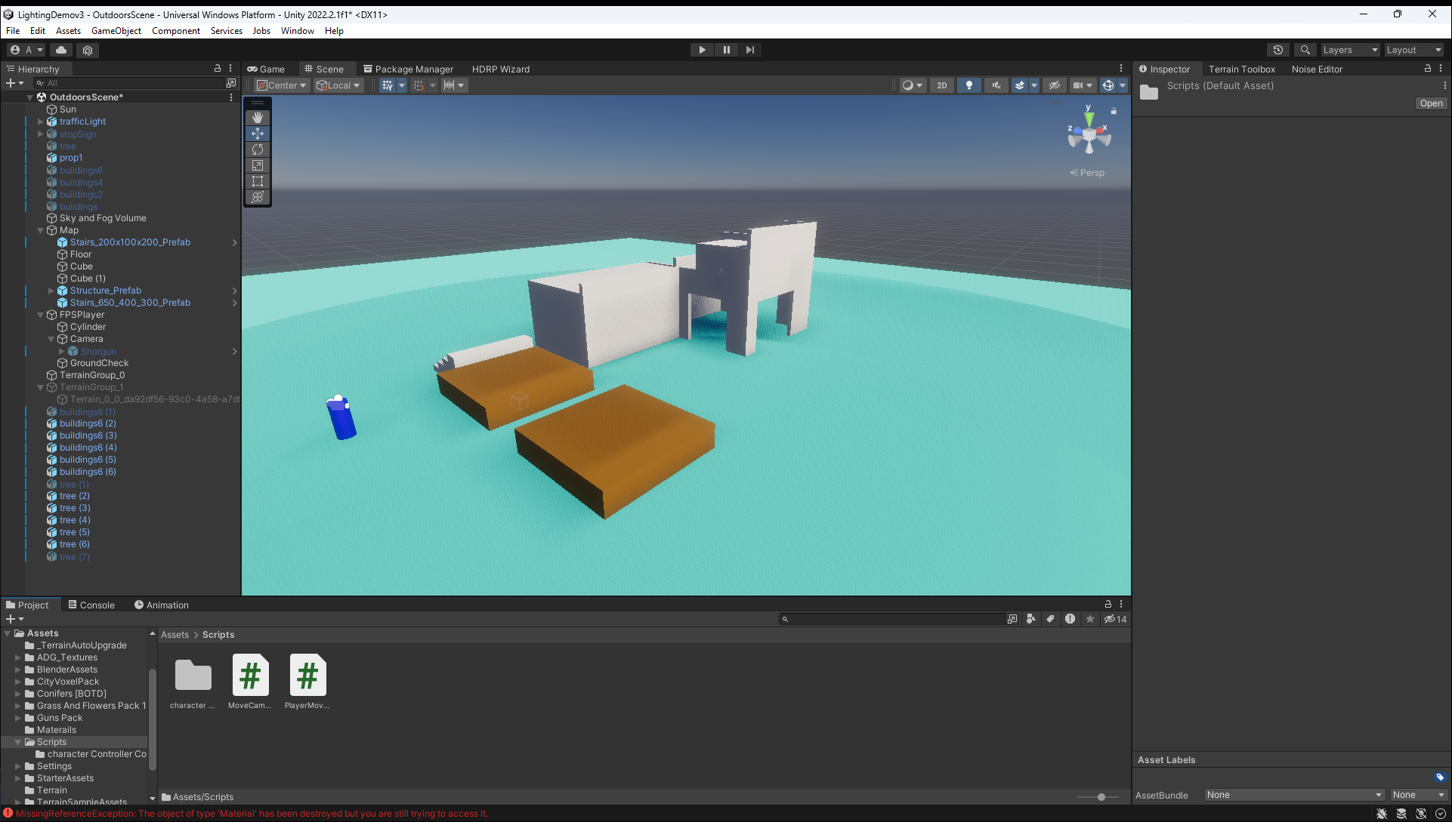

# Week 2 (6)

23/01/2023 – 27/01/2023

## Independent Research / Study

Started making blender models.

I followed a YouTube video on making a low poly building in blender.

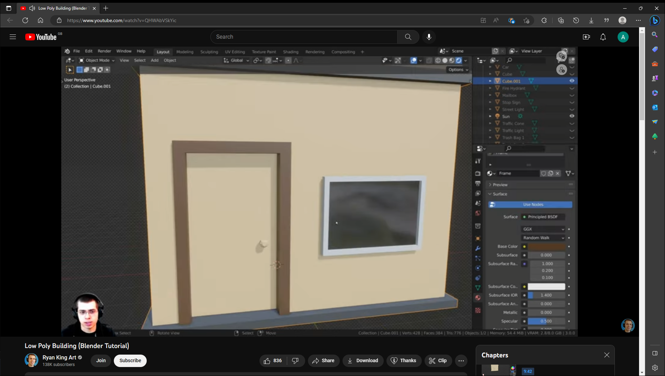

After making the building myself, I then made many other models by looking online for images and then remaking them by following the images.

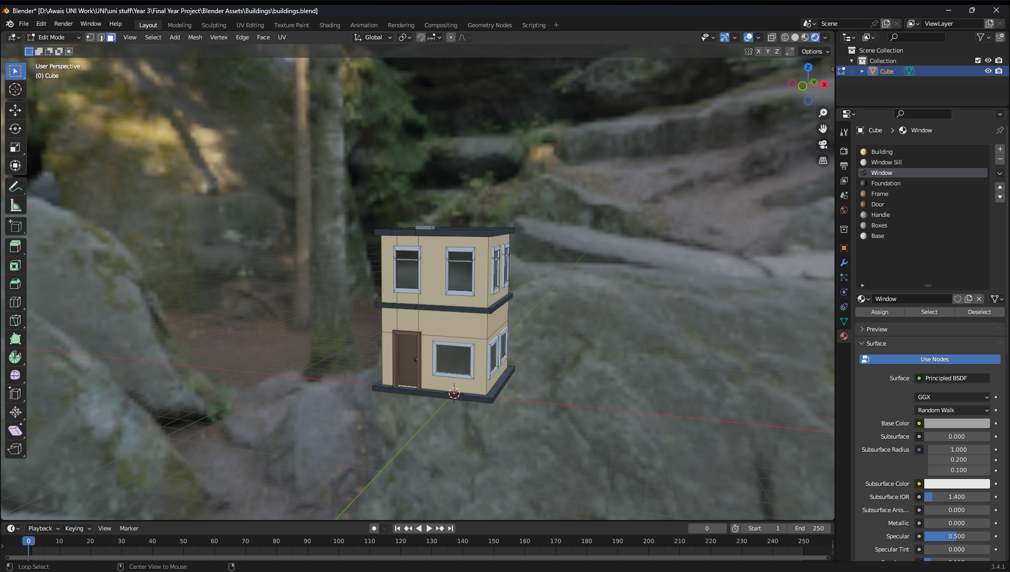

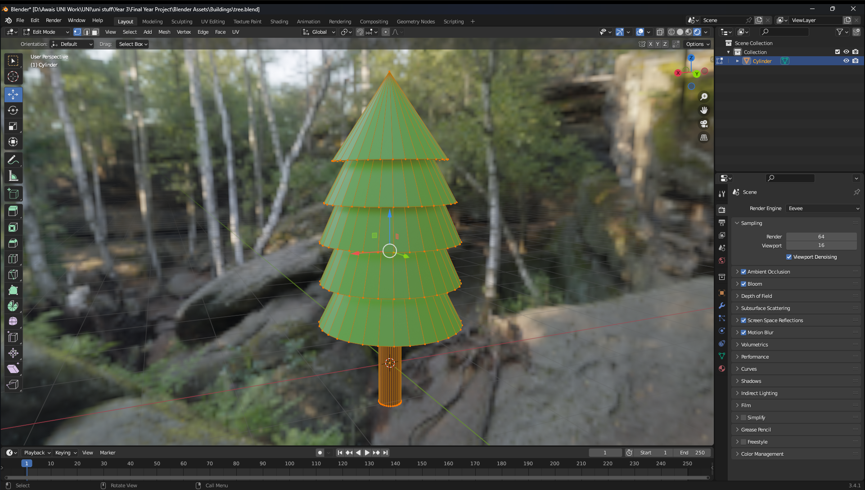

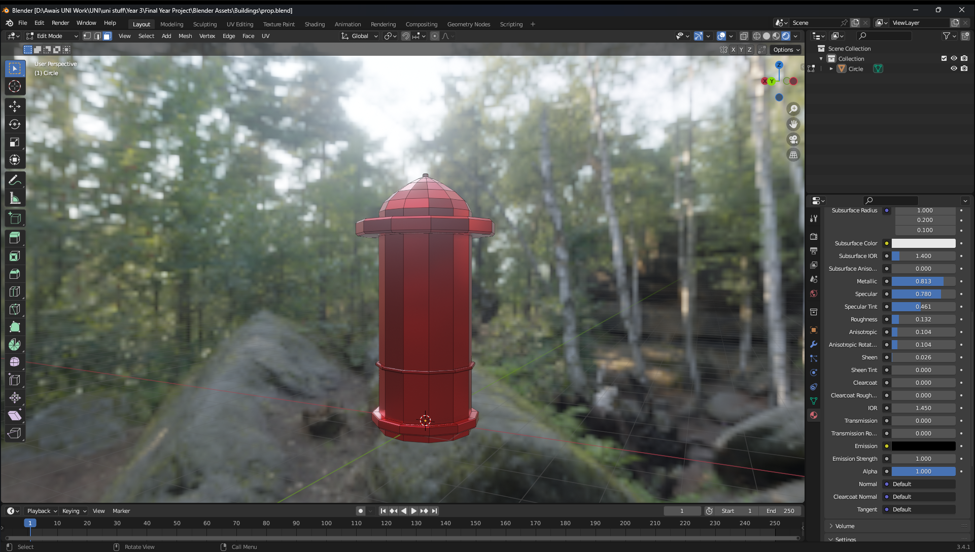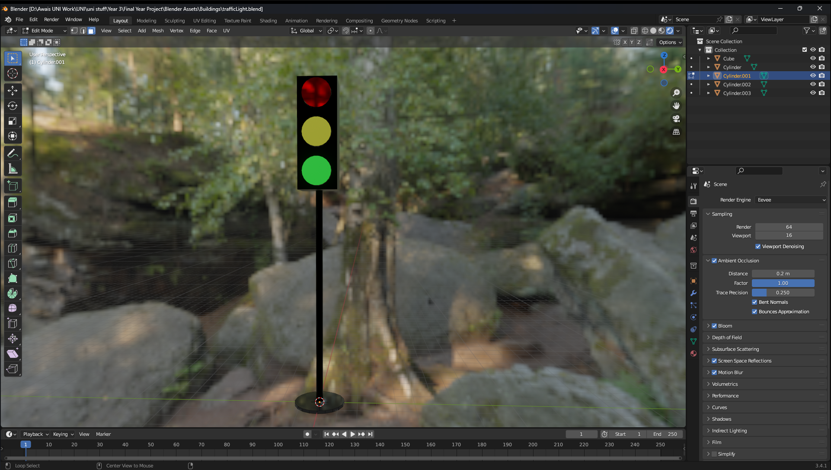

# Week 3 (8)

30/01/2023 – 03/02/2023

## Independent Research / Study

The MVP demo was due this Friday (Demo Due Date – 03/02/2023) so I have been fully focused on this project.

I have added the models to unity and have tested that they look proper.

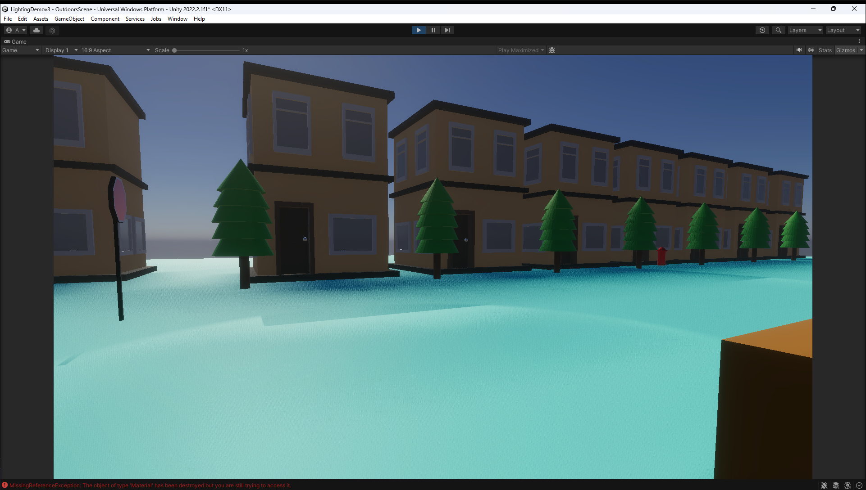

After the models where added, I then started to make a terrain and added vegetation to it. I followed another Brackeys tutorial to do this.

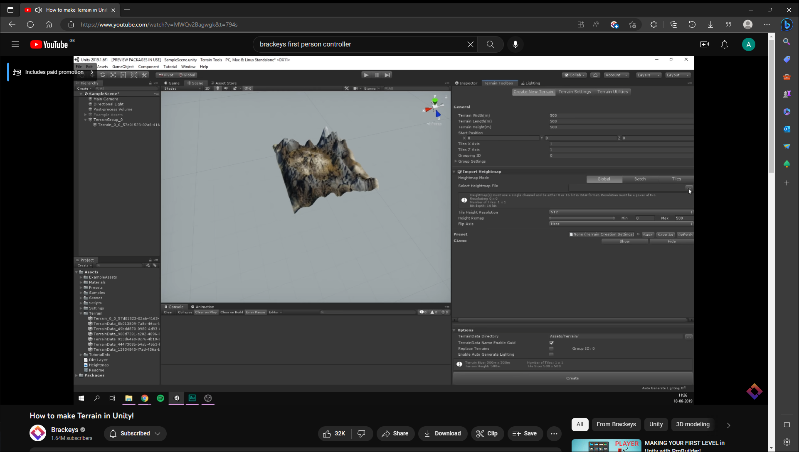

Once the terrain was, I did a test to make sure everything was working. I had a small issue when walking on the terrain, I kept falling through it. To fix this I added a box collider to it to make sure I wouldn’t go through the map.

I have demonstrated the MVP to Lee, and he has stated that I am on track to finish the project. The main feedback that he wanted was that I need to think about incorporating a security aspect to the game. This will be done later down the line.

# Week 4 (8)

06/02/2023 – 10/02/2023

## Independent Research / Study

This week I made the corridor part of the level 1. I made the layout of the corridor by using cubes and expanding them out and moving them around. Then I added some area lights to the first part of the corridor. After this I added spotlights to the 2 small hallways that go from corridor 1 and 2.

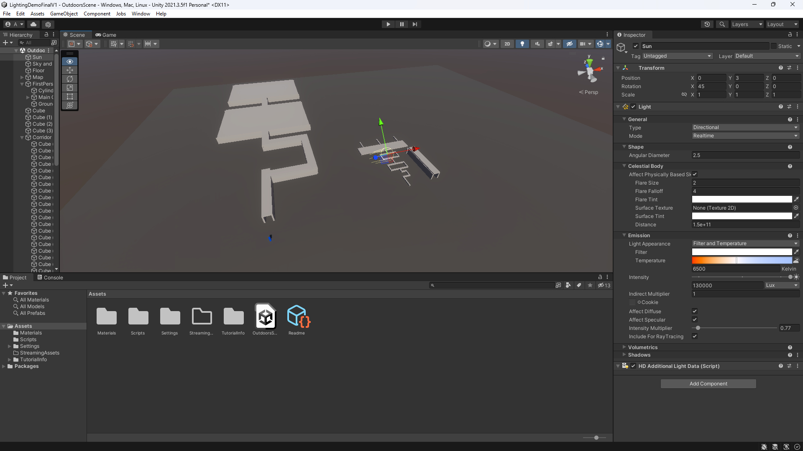

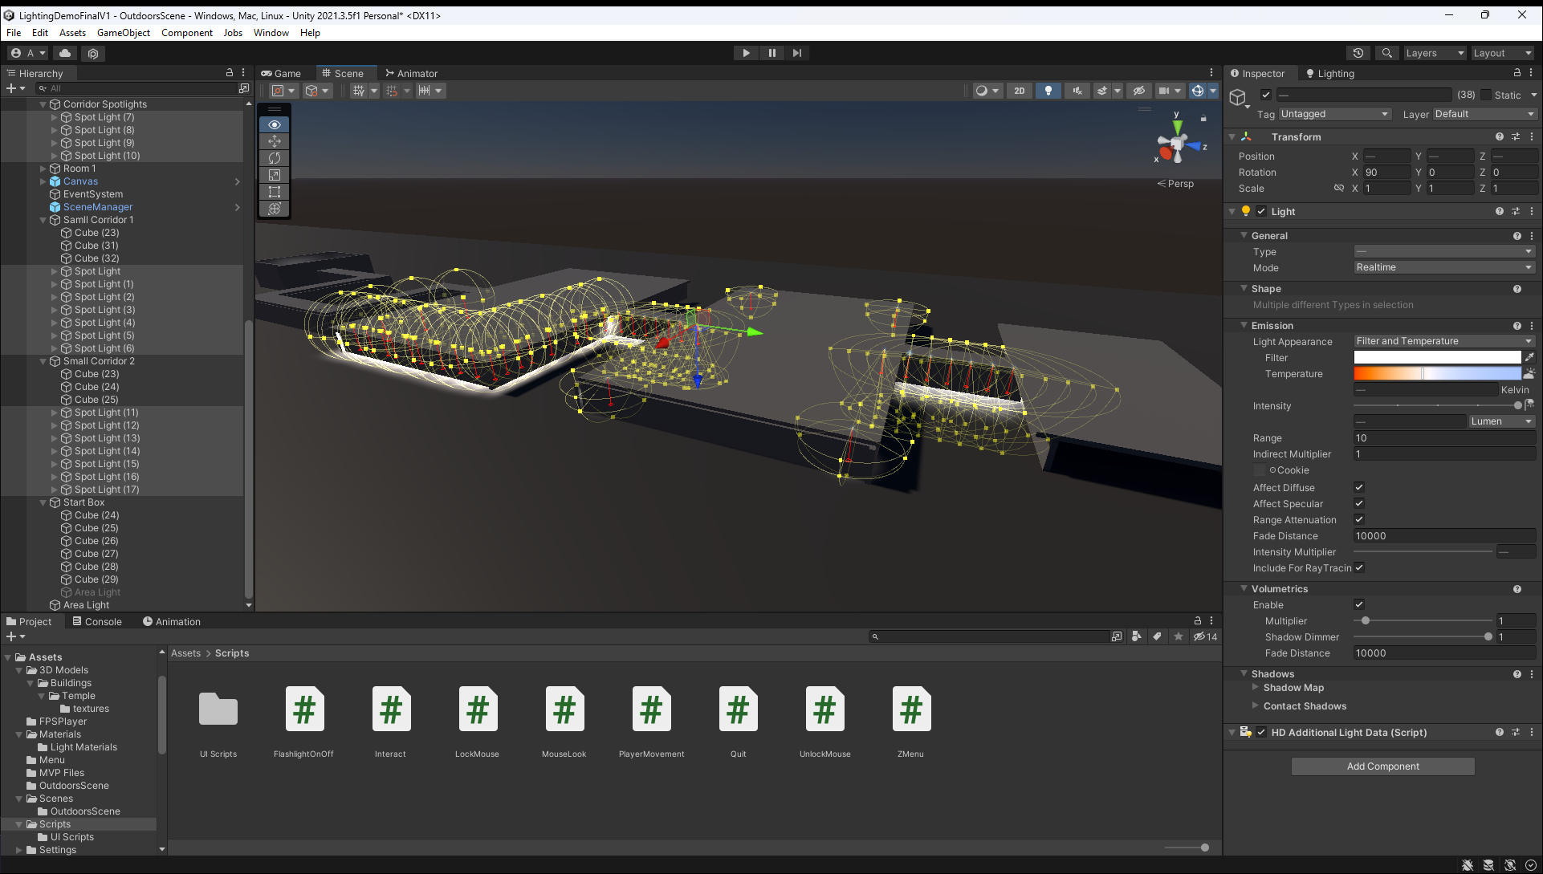

After this, I added the character controller. I took the code for the MVP, but I added mouse locks to it so that it would be easier to use the UI.

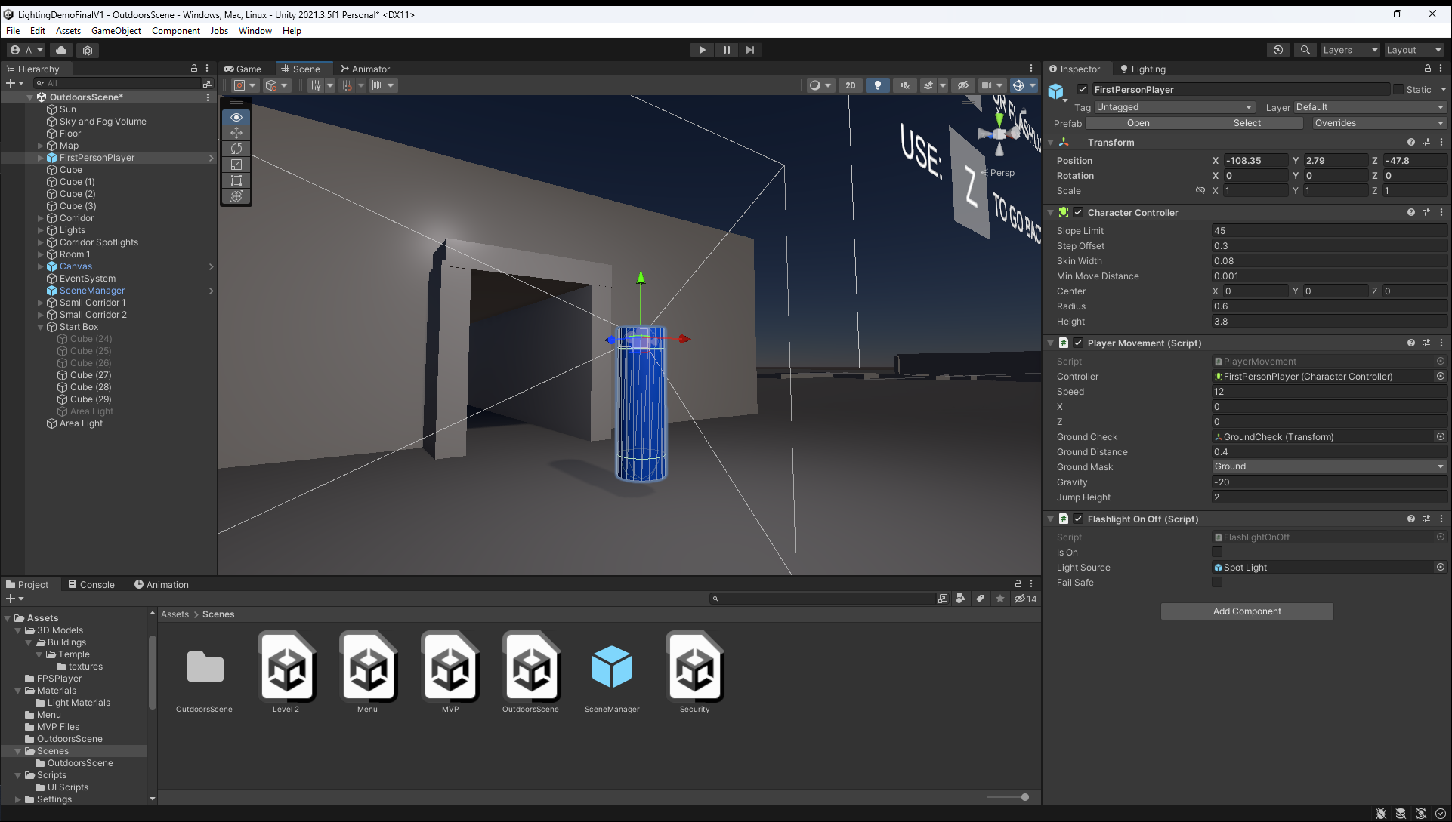

After the character controller I added a flashlight to the player. There was a bug where the flash wouldn’t turn off, but this was fixed by adding a delay.

I then tested the game on my HP laptops, and they worked.

# Week 5 (8)

13/02/2023 – 17/02/2023

## Independent Research / Study

This week I fine tuned the lighting for the corridor by manipulating the lighting settings in unity.



After this was completed, I started work on the lighting room which is the demonstration of baked lighting. I first downloaded 3d models from an online asset store.

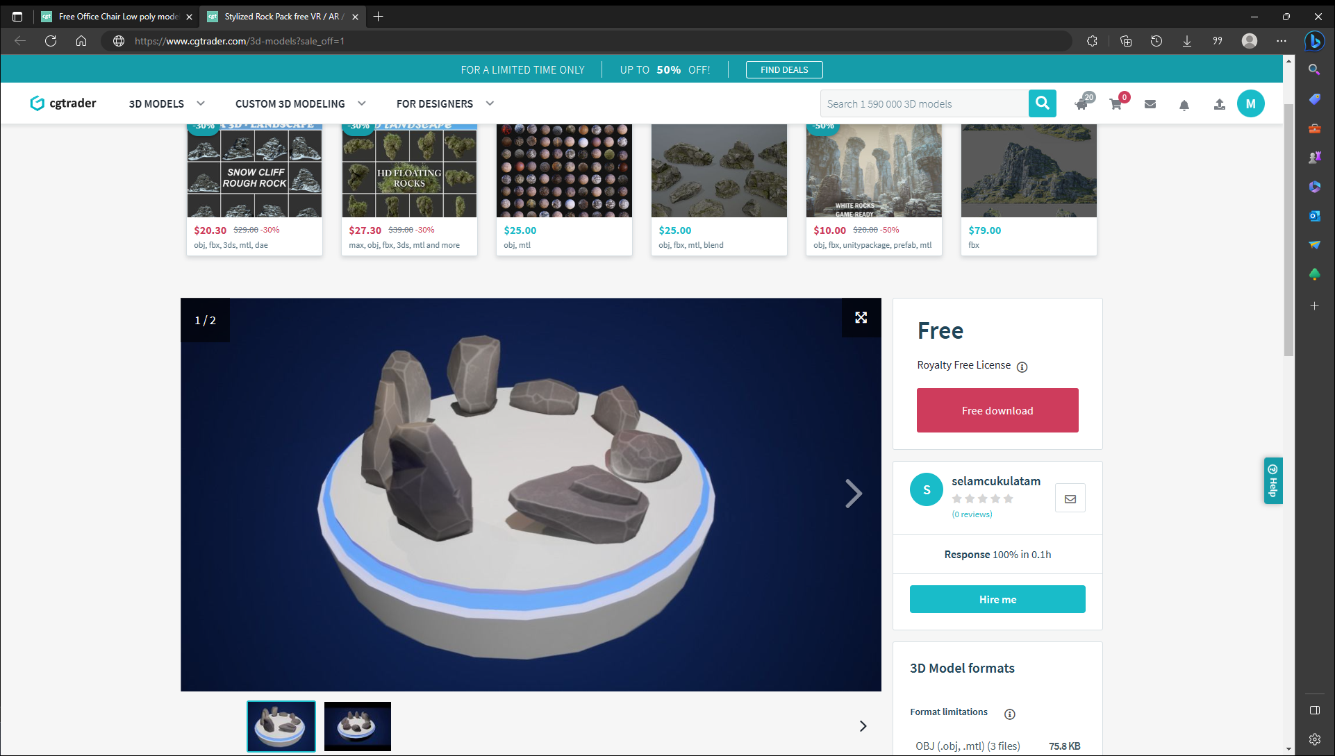

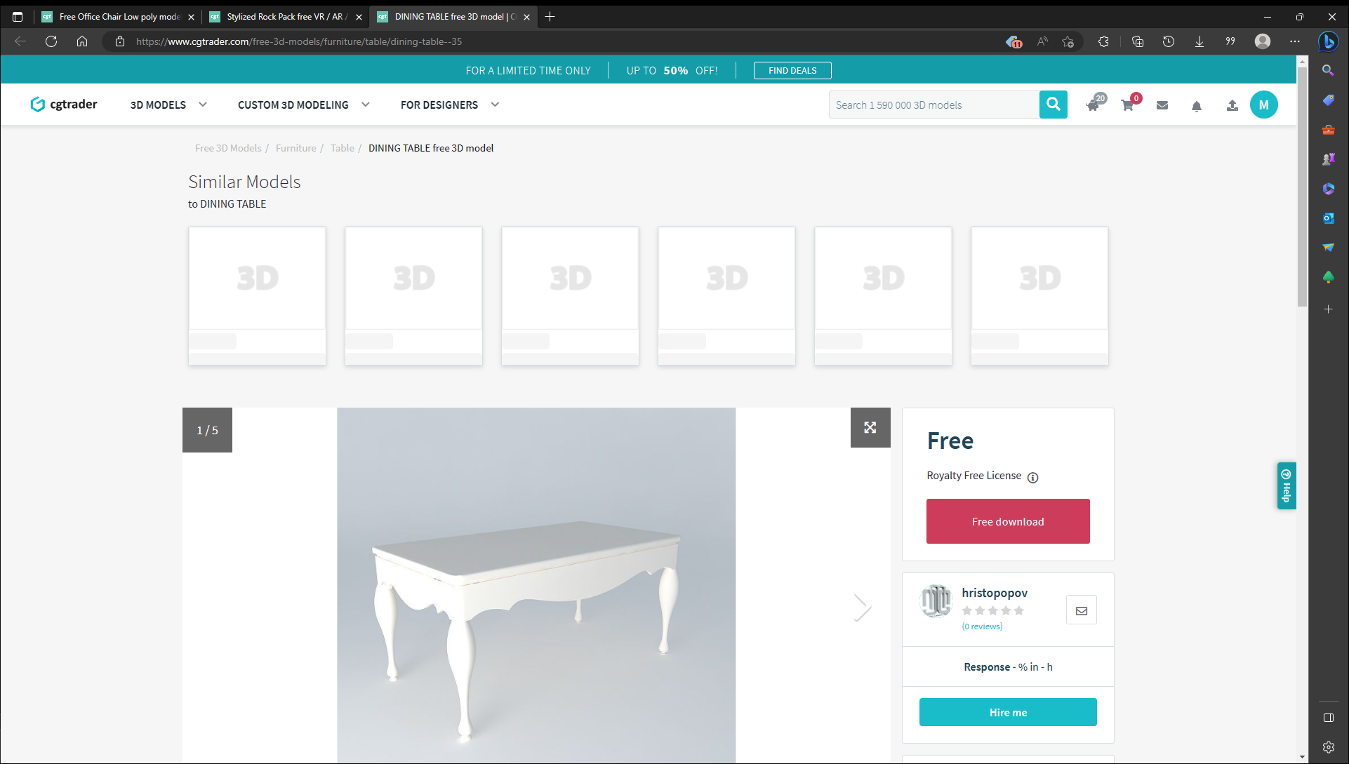

Then I imported them into Unity and added them to the demo room.

Then I added pane to the left and right walls and one pane to the ceiling. Then I created an emissive material that would shine light out. After this, I attached the materials to the pane and then baked the lighting. When I first baked the lighting, it took 10 minutes as it was baking on the CPU, then I changed it to bake on the GPU. I did this a few times to get the perfect lighting and atmosphere for the room.

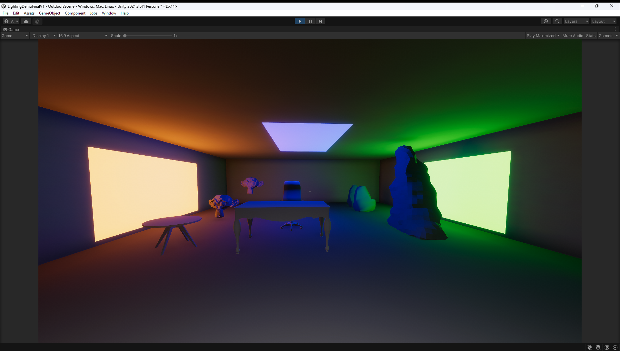

# Week 6 (8)

20/02/2023 – 24/02/2023

## Independent Research / Study

I have now started work on the second level of the demo. This level is based on real time lighting. I first added a directional light to the scene, this acts like a sun. After this I added a floor to the scene.

Then I created a character controller and tested the movement in the game. After this I did some research on lighting techniques in unity and how to use real time lighting.

After researching, I needed to create a map for the player to walk through. This was done by using premade assets from a website called’ DevAssets’.

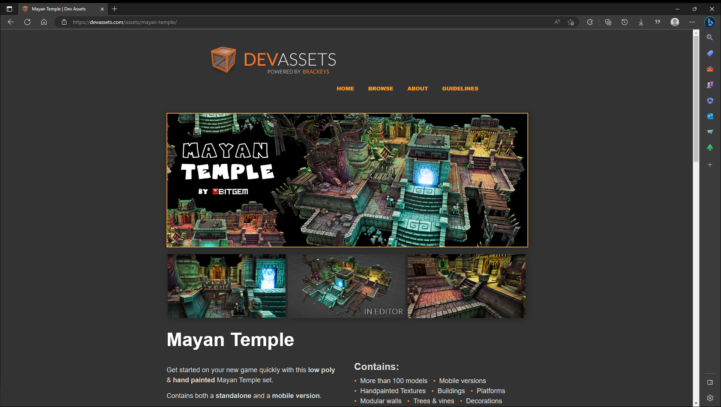

The downloaded model gave lots of small to make a temple in anyway that I like.

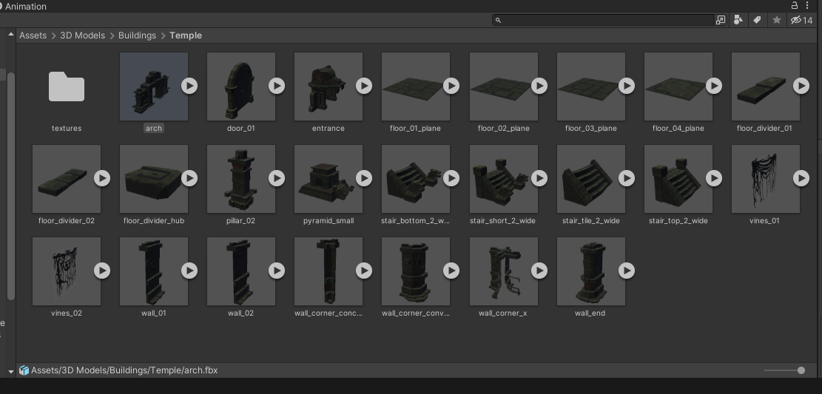

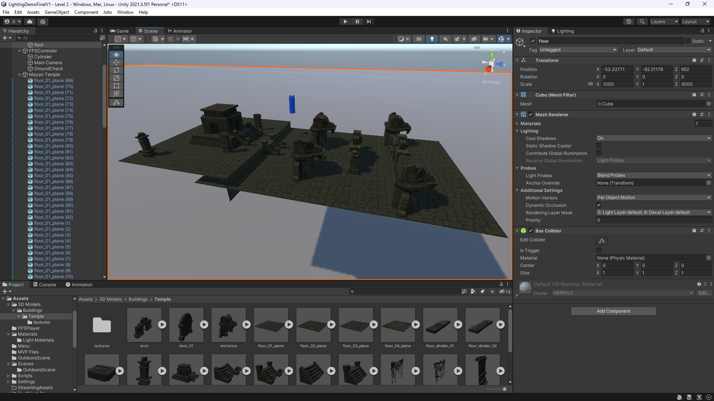

This is the map that I made using the premade assets. This took quite some time and lots of trail and error. After this was made, I tested it on my HP laptops to see if they worked which it has worked.

Week 7 (6)

27/02/2023 – 03/03/2023

Dr Jullian Bass gave a lecture on dissertation writing.

Julian talked about how we should structure our dissertation. He also requests that we keep making drafts and have the drafts checked with our supervisor. He also showed a template structure of a dissertation. So far, I have followed the template for this. He also states that we should contact our supervisors about our heading and sub-headings to get the correct ones.

Julian recommends that we apply a lean software methodology to our writing, which is, eliminate waste, aim for perfection, features are pulled, flow. He also gave 2 writing process, which are top down and bottom up.

Julian also talks about science writing, which is evidence based, factual, carefully organised and has a logical flow of arguments. Julian also talks about the writing style of a dissertation, which includes, make paragraph unit of composition, begin each paragraph with a topic sentence. Use active voice, remove needless words, write in the positive and be concrete.

## Independent Research / Study

This week I added all the lighting to the scene and all the box colliders to the scene so the player can walk in the temple.

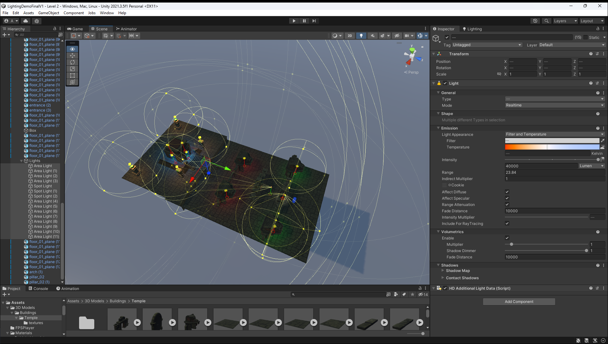

These are the area lights and spotlights with the different colour lighting in the level.

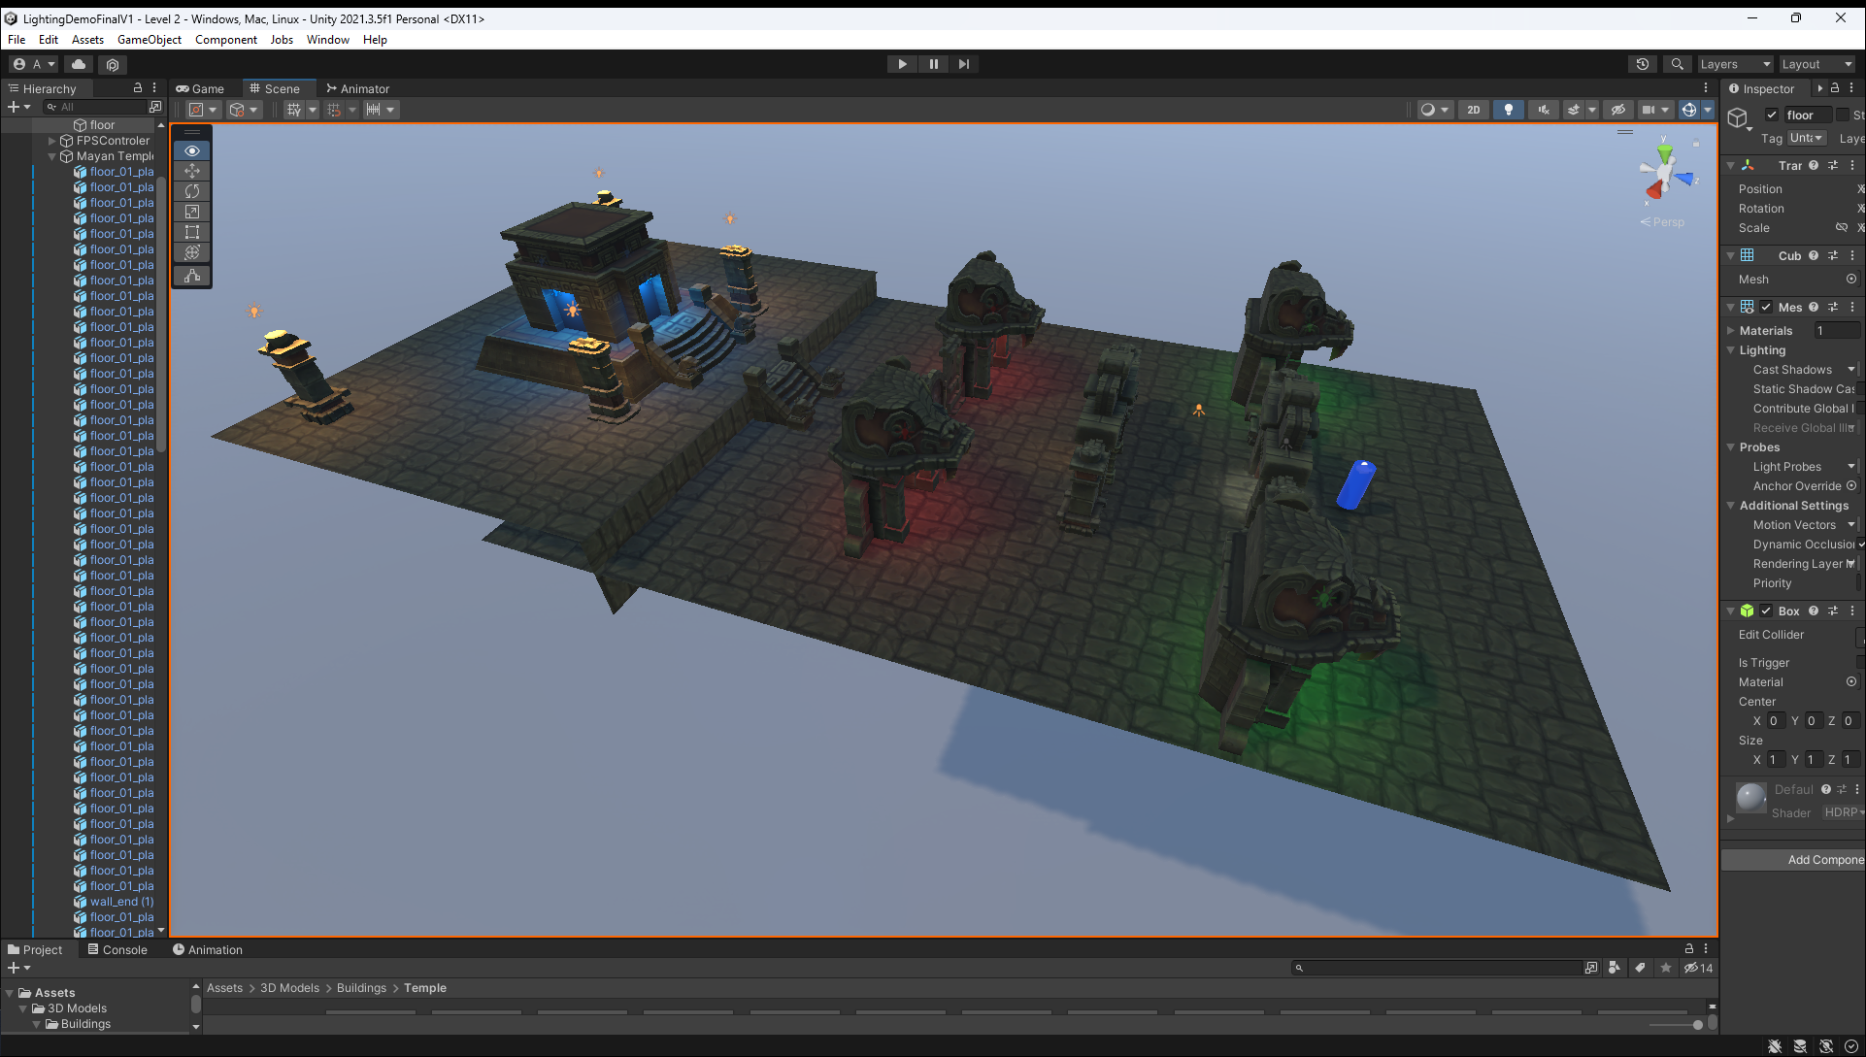

This is the final look of level 2 after it has been completed.

# Week 8 (6)

06/03/2023 – 10/03/2023

## Independent Research / Study

Level 3 and dissertation

This week I have divided my attention into 2 parts, the first half I focusd on getting level 3 done, the second half I focused on the design and requirements part of the dissertation.

This level is quite a simple level in graphics and lighting, as this levels focus is on the security aspects of the project. There main idea for this level is to inform the player about the security issue and how to avoid them. To do this the player needs to walk up to an alter and interact with it and it will bring up a dossier of information.

The first thing that I did was do research on security new stories. I picked 4 of the stories, GTA 5 Online hacks, CDProjekt Red source code Leak, Call of Duty: Black Ops 3 remote access trojan hacks and Sony PlayStation live hack.

Then I created the alters where these stories should go.

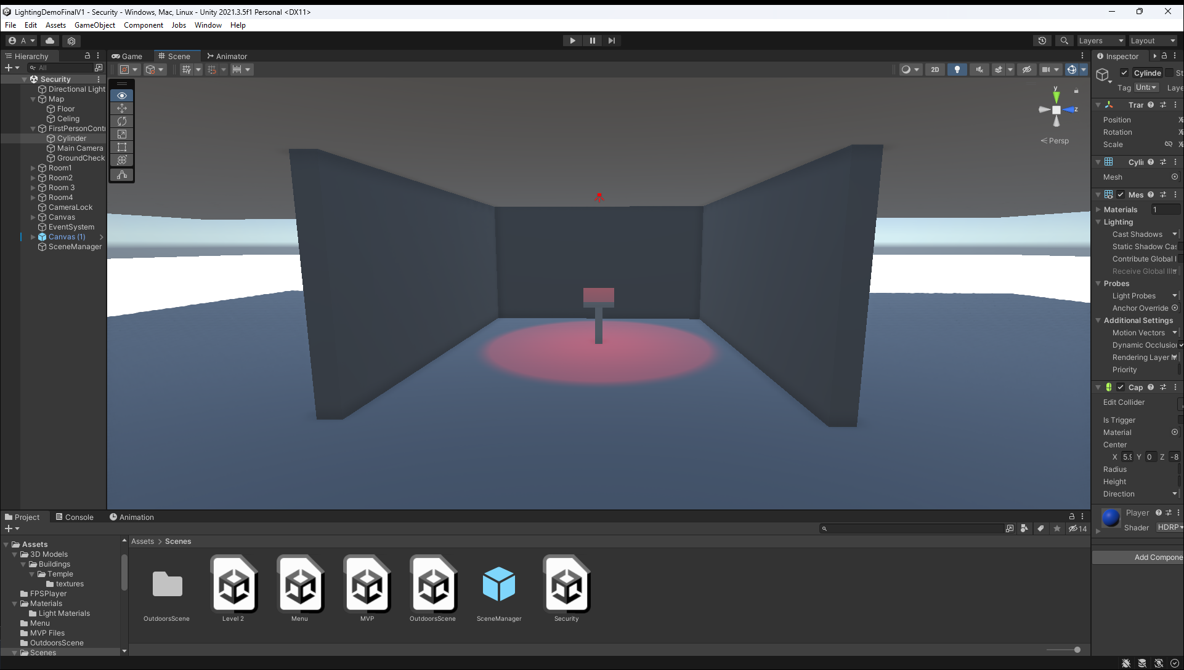

The second half was focused on the dissertation and trying to get the design and requirements part finished.

Week 9(8)

13/03/2023 – 17/03/2023

Dr Norman Murray gave a lecture on Final Year Projects Deliverables

Norman has given a layout of the dissertation which is:

• Abstract

• Introduction

• (Literature Review)

• (Methodology)

• Requirements

• Design

• Implementation

• Testing

• Critical Evaluation

• Conclusions

Norman also explains each section of the dissertation. He also gave a timetable for the demonstration which is going to be scheduled for week 12 of trimester 2, 24th April 25th April. 26th April is a backup date. He talks about the 3 parts of demo which are, 5 -10 minutes presentation, 5 - 10 minutes demonstration on what has been developed and 5 minutes for questions.

## Independent Research / Study

Near the end of the week, I began to feel ill, and then I found out that I had gotten covid. Sick from 16/03/2023 – 22/03/2023

This week I finished level 3 by added the stories to the game and implementing an interactable script to the scene, so when the player walks near the alter, a UI element will pop up that says press the ‘E’ key.

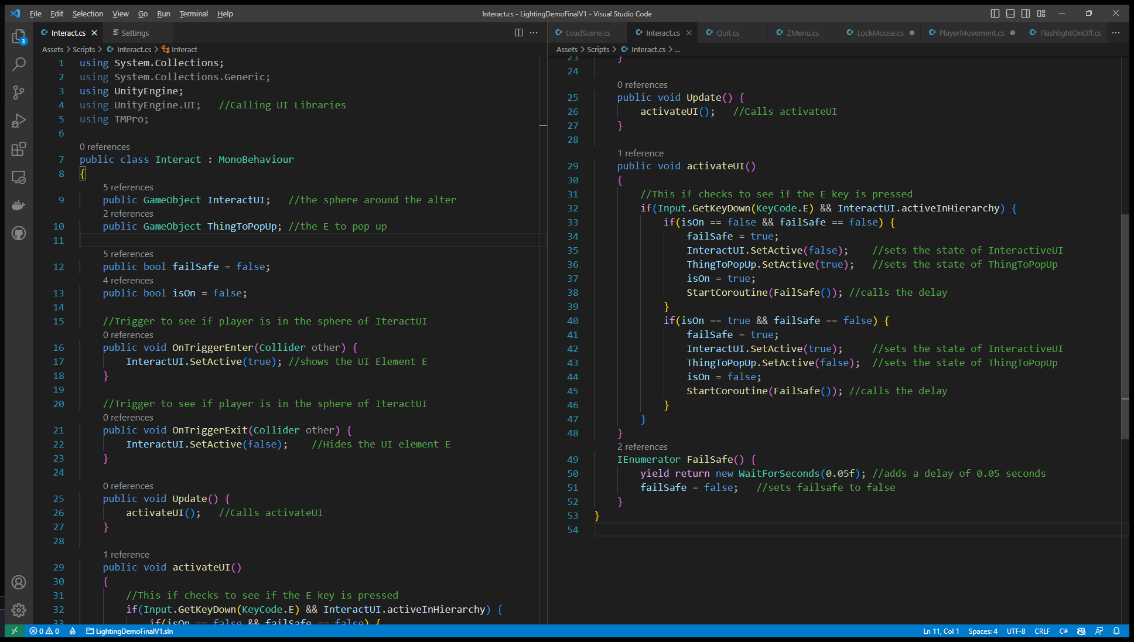

After this I added a main menu to the game and then I added the animation for the main menu aswell. Then I add a HUD to all the levels where it gives instructions on how to walk and turn on the flashlight. There is an animation on this aswell, where the instruction goes off the screen after a few seconds.

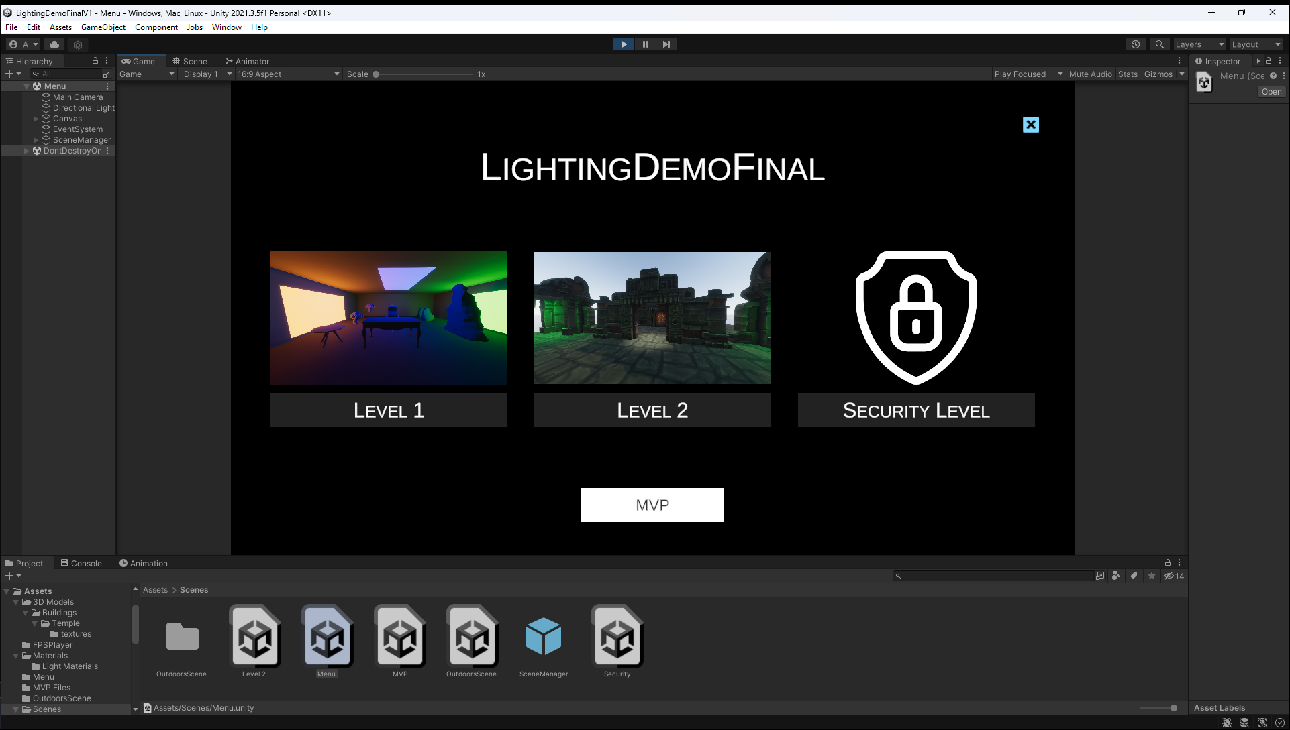

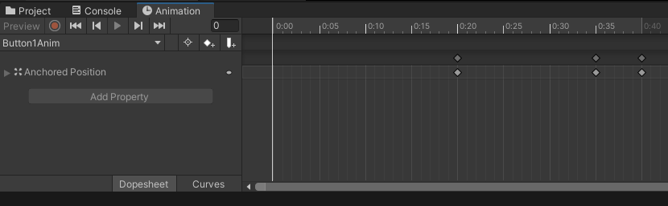

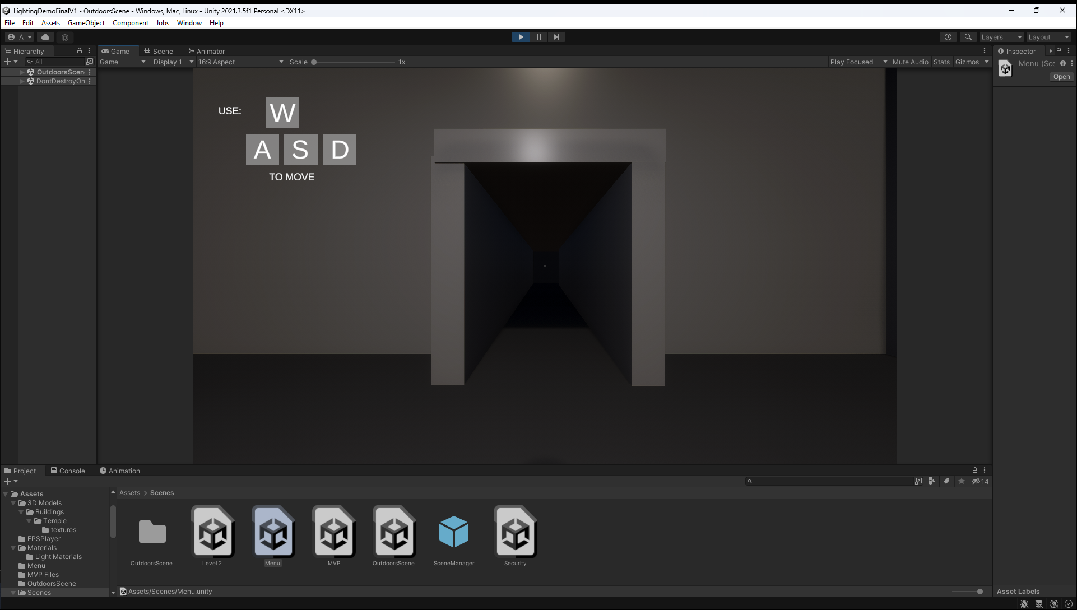

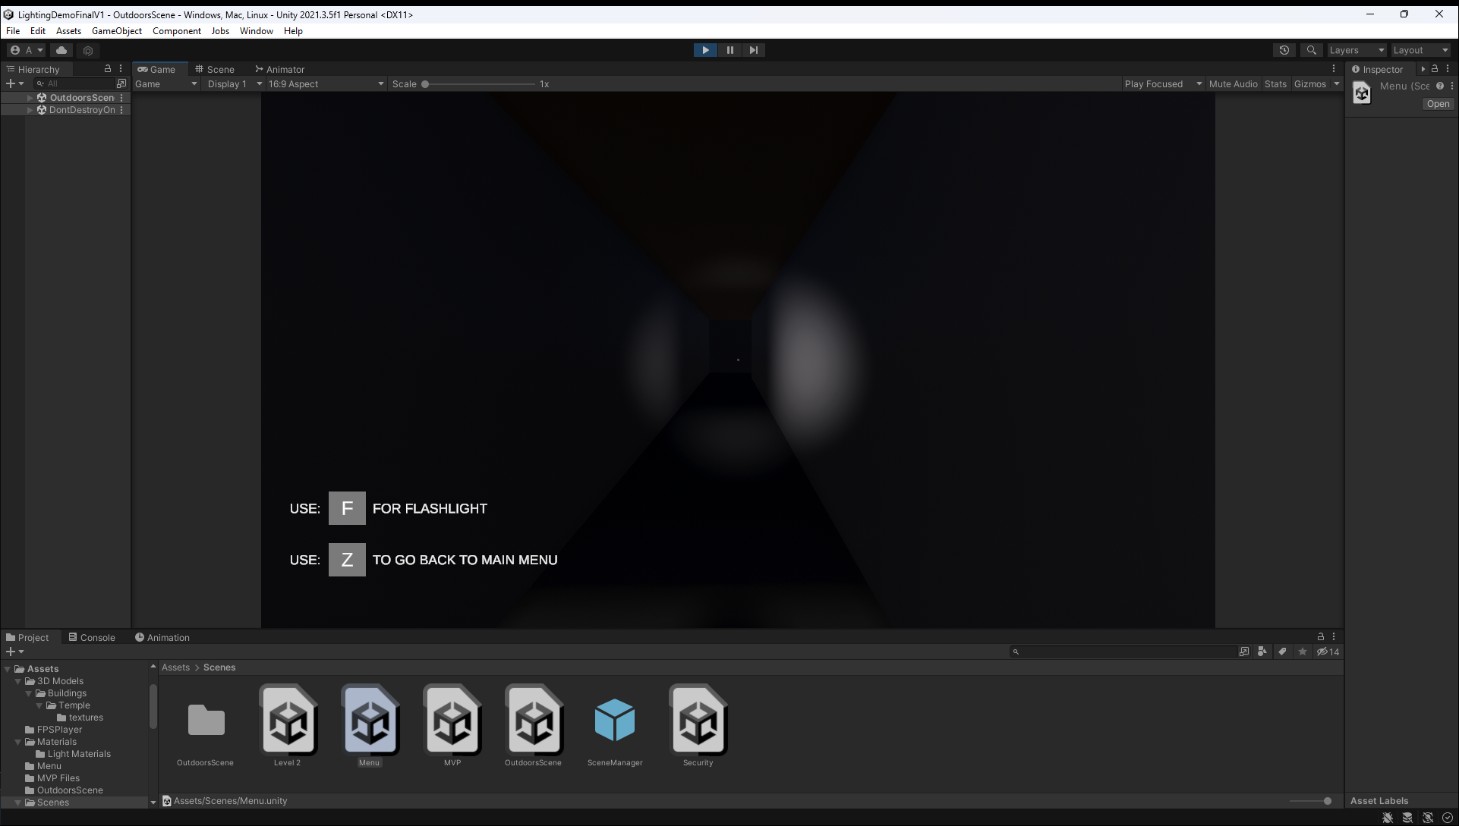

I also finished of the design and requirements part of the dissertation.

## Week 10 (2)

20/03/2023 – 24/03/2023

## Independent Research / Study

Sick from 15/03/2023 – 21/03/2023

After recovering from Covid, I checked my dissertation and then I emailed it to Lee.

I then carried on working on the other parts of the dissertation.

## Easter Holidays - 27/03/2023 – 16/04/2023 (30 hours)

I went to university on the 28/03/2023 to do a test the lighting demo on the University computers, unfortunately the demo did not run on the university computers as the unity version where mismatched and the built version of the game didn’t run because I the permissions didn’t work. This is when I became really stressed as I didn’t have a powerful enough portable machine to take with me to the demonstration in late April. I decided to go back home and port my entire demo over to the University installed version of unity which is version 2021.3.5f1.

After porting the game, I went back to university on the 04/04/2023 to test the lighting demo again. Luckily this time it had worked, and the game ran successfully.

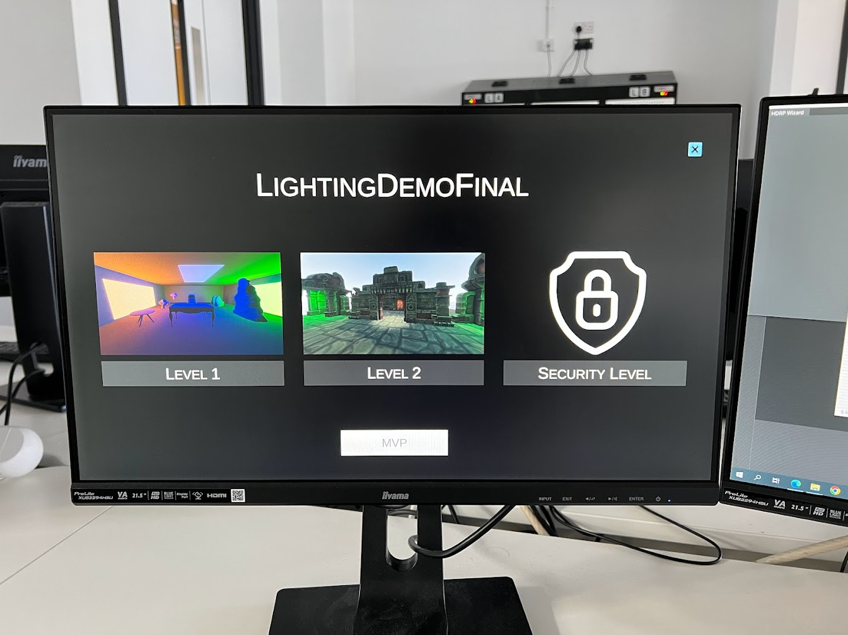

After testing the game in university, I finished off my dissertation.

Emailed the full dissertation to lee for feedback.

## Week 11

17/04/2023 – 21/04/2023

17/04/2023 is dissertation and project submission date.

Week 12 is Demonstration Monday April 24th and Tuesday April 25th.